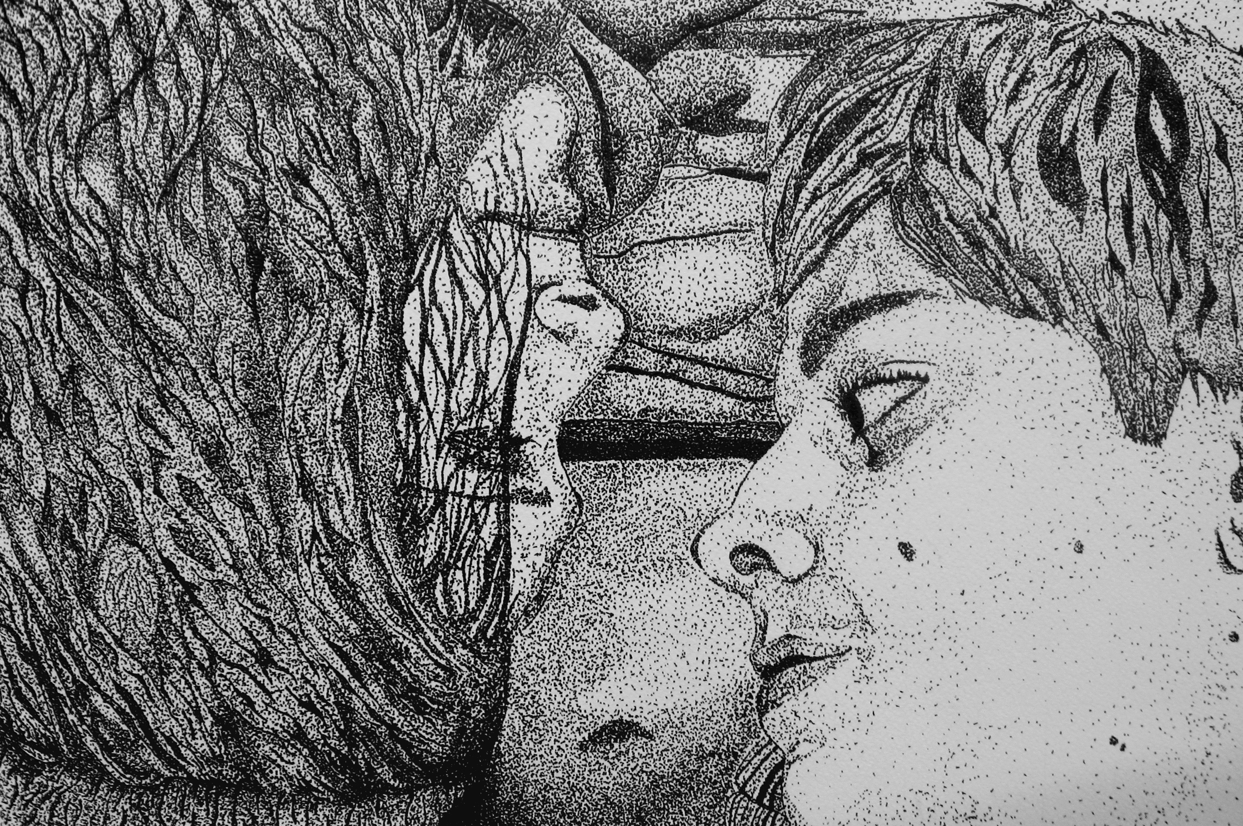
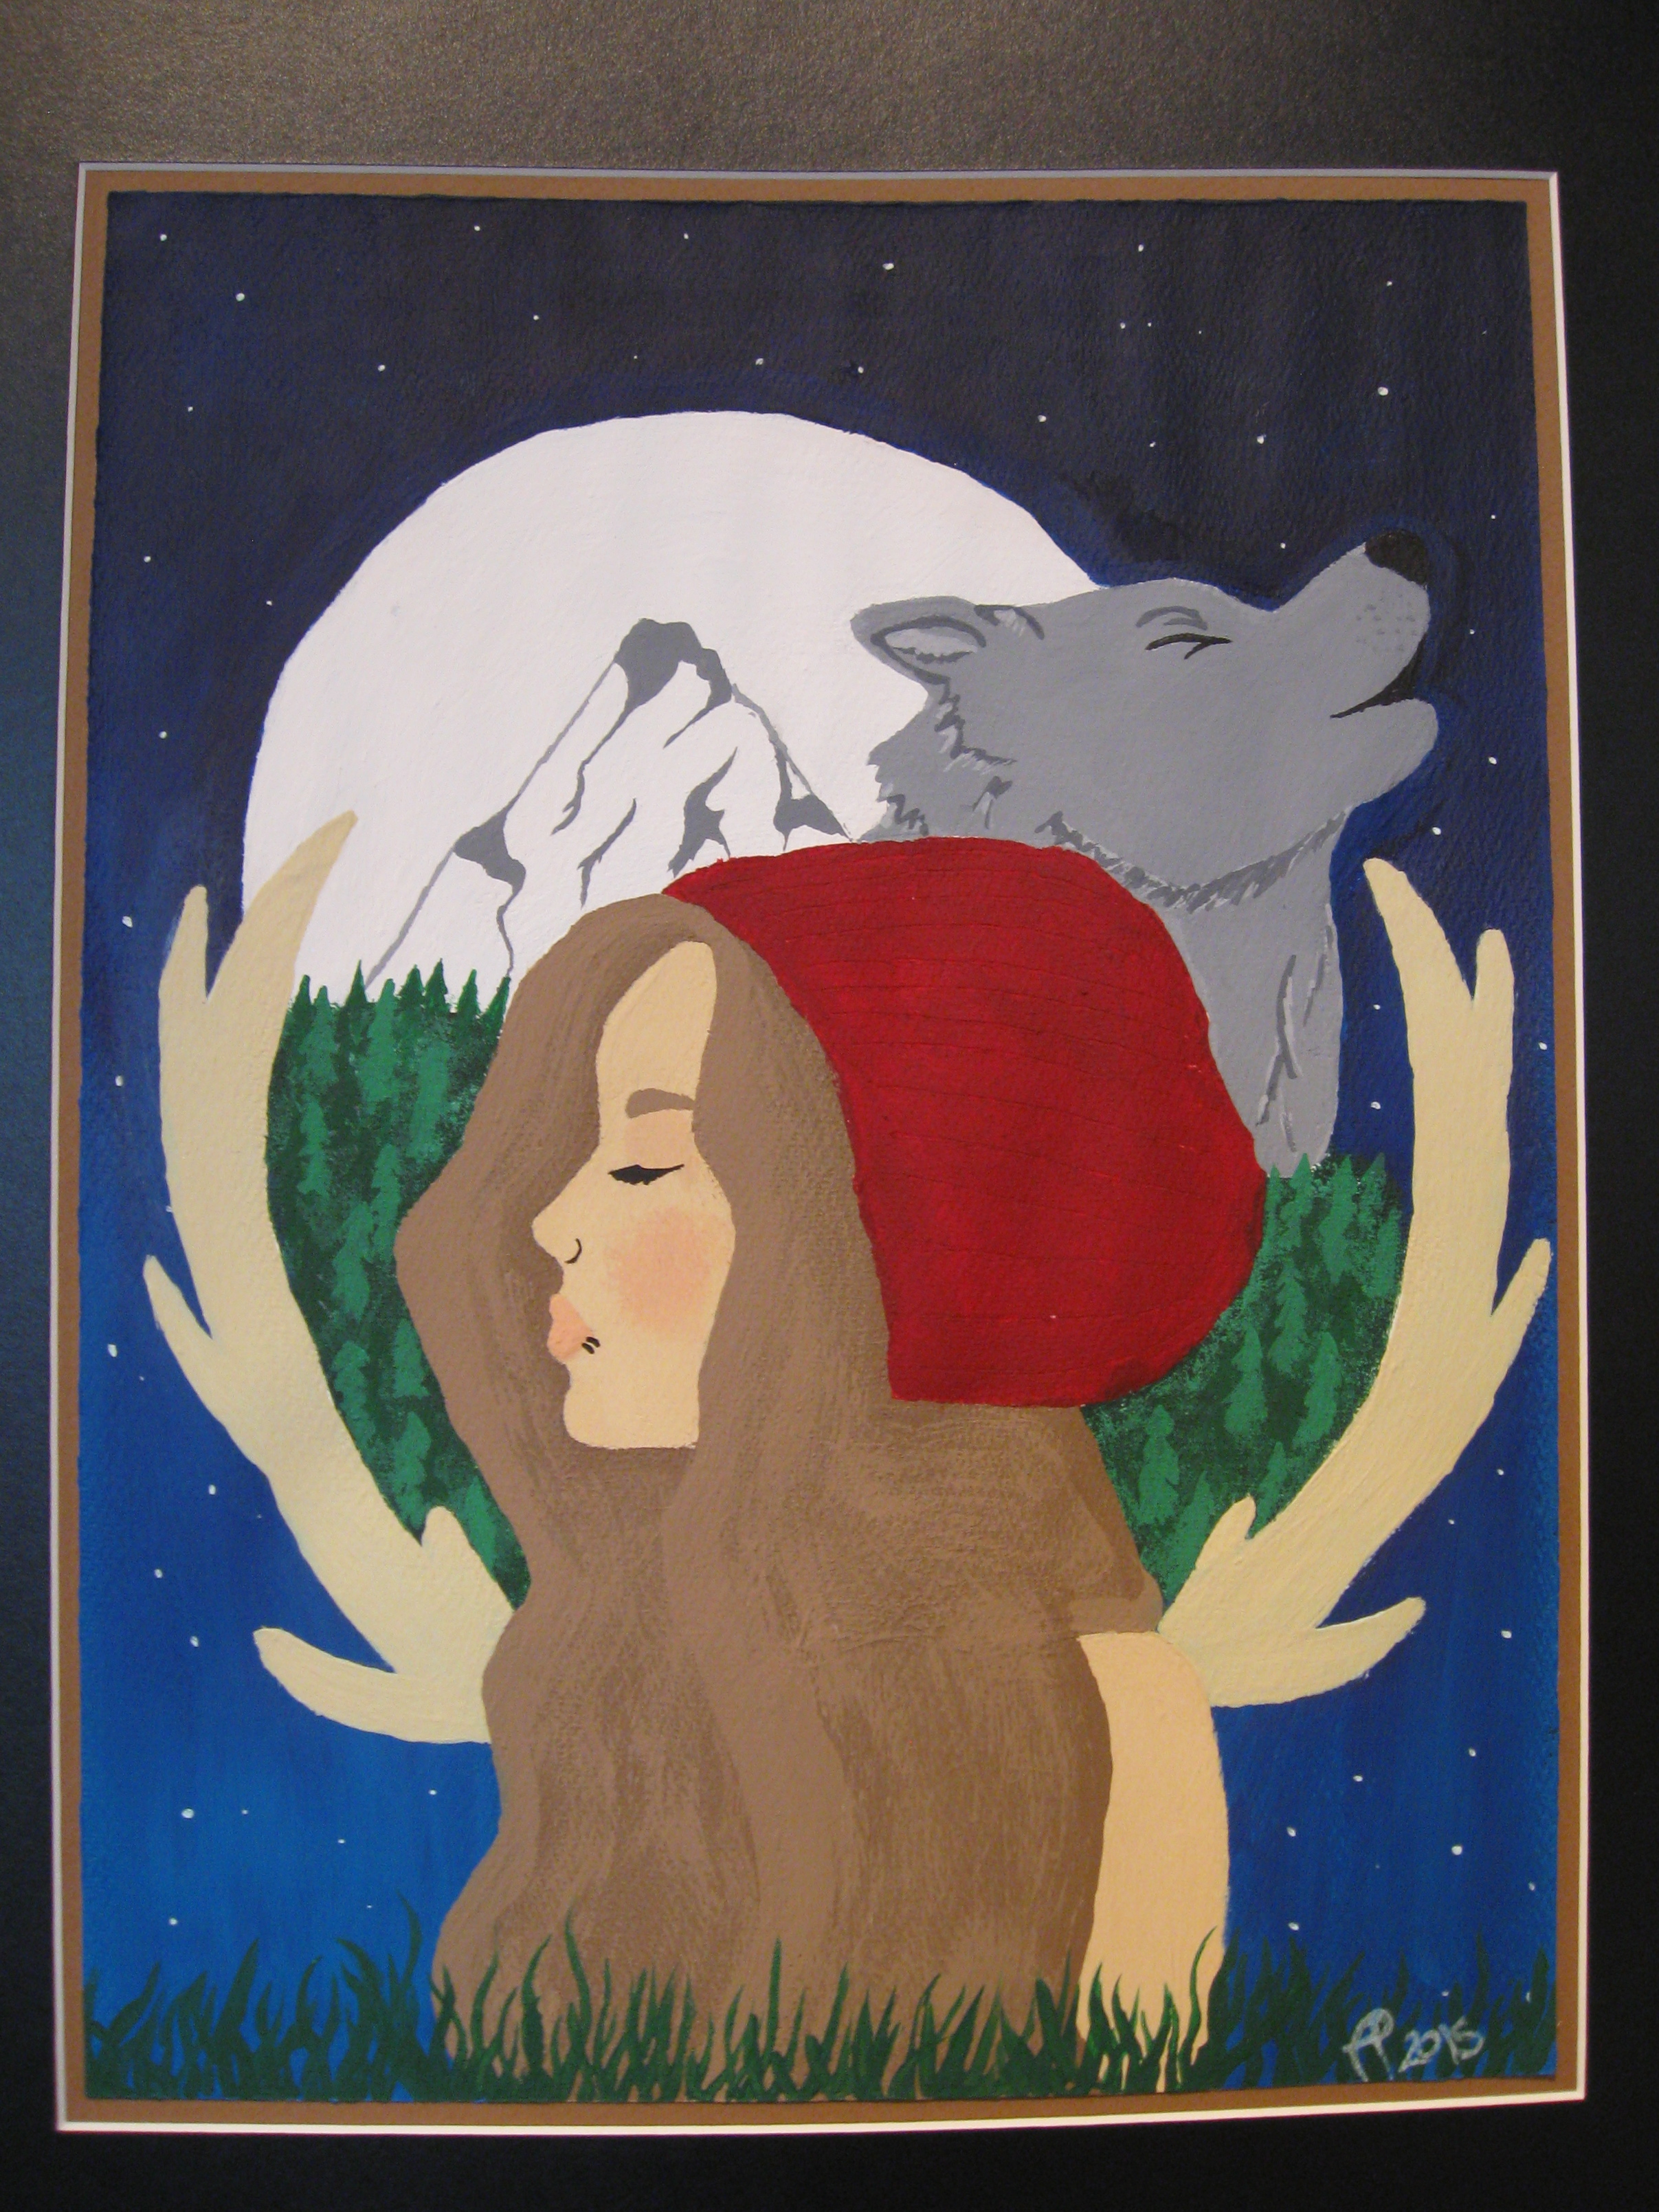
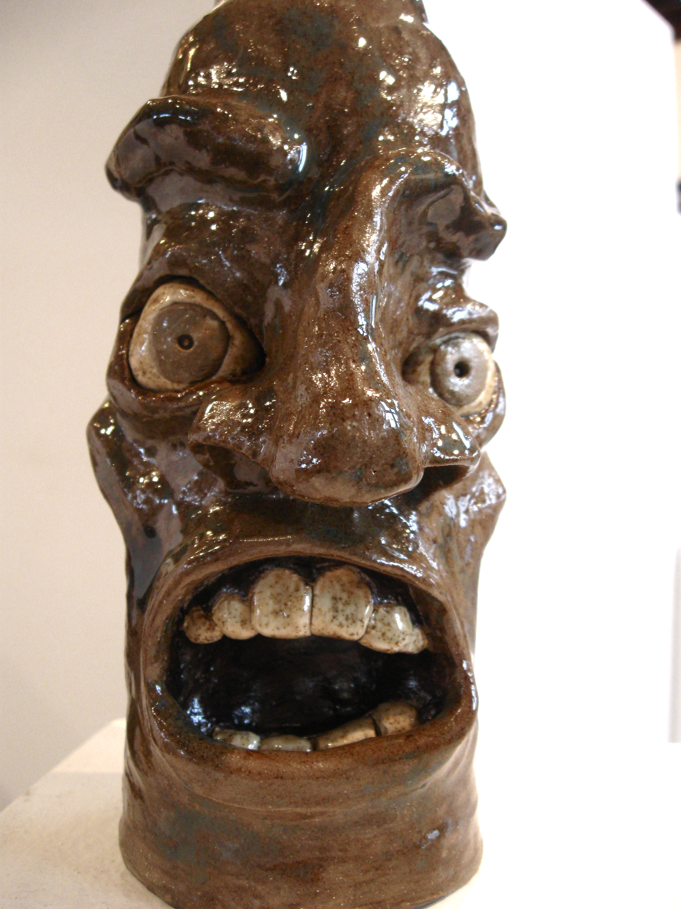
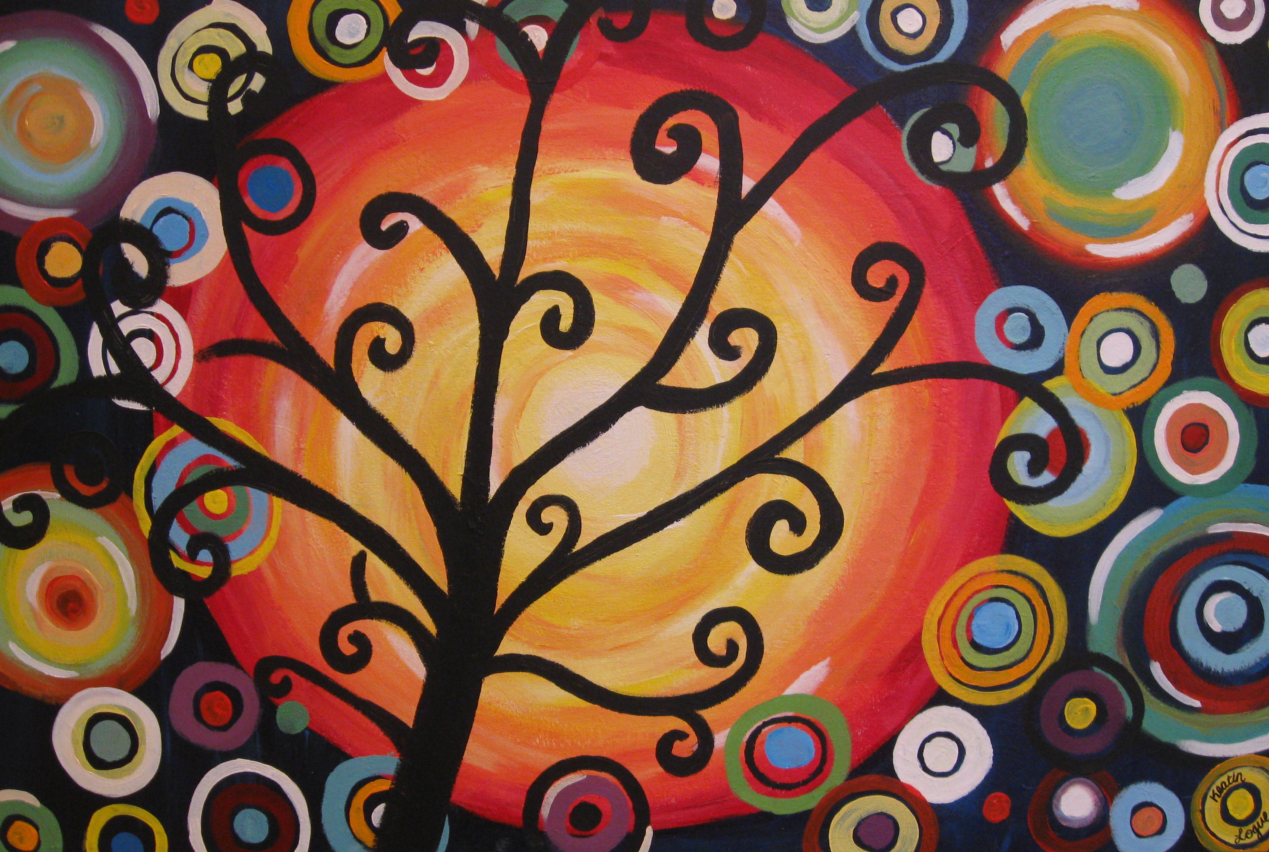
The Dalles Art Association
220 East 4th Street The Dalles, Oregon 97058 (541) 296-4759
thedallesart@gmail.com www.thedallesartcenter.org
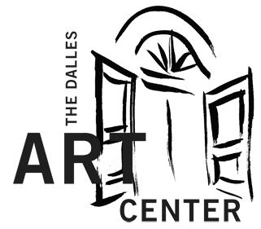

Dear Middle/High School Arts Instructor:

The Dalles Art Center would like to invite your art students to participate in our 2019 Mid Columbia Middle & High School Student Art Show for grades 6 - 12 at The Dalles Art Center. We know that a lot of work goes into the prepartation of a show like this, so we are letting you know ahead of time that we shifted the submission dates.

Entries will be accepted Tuesday, February 5th through Friday, February 8th, 2019.

  - Only one entry per student. Entry forms are on the back of this invitation. Please feel free to make copies or download a form from our webpage.
  - Any form of artwork and medium is acceptable.
  - Pieces should be neatly presented, and spray fixed if pastels were used.
  - Flat work (drawings, paintings, etc.) must be mounted on poster board and be ready to hang with a simple line across. Work does not need to be professionally framed.
  - Please have students sign their work. Provide a typed list of participants at drop off.

The Middle and High School entries will be judged separately. If there are enough entries, we will also separate 3D from 2D submissions for judging. All artwork will be evaluated for the following:

    - Originality
    - Presentation
    - Composition
    - Skill w/ Medium

The Exhibit will run February 12th through March 2nd, 2019 at The Dalles Art Center with a Closing Reception on Saturday, March 2nd from 3-4pm. Awards will be handed out at the reception and students will take home their artwork afterwards.

Please feel free to share this invitation with any other arts instructor within the Mid Columbia area. If I have missed an instructor, please contact me with their information. Thank you for your help and continued support of the arts in our communities. If you have questions, please call me.

Yours truly,

Lettie Young
Assistant Director
The Dalles Art Center

541.296.4759
thedallesart@gmail.com

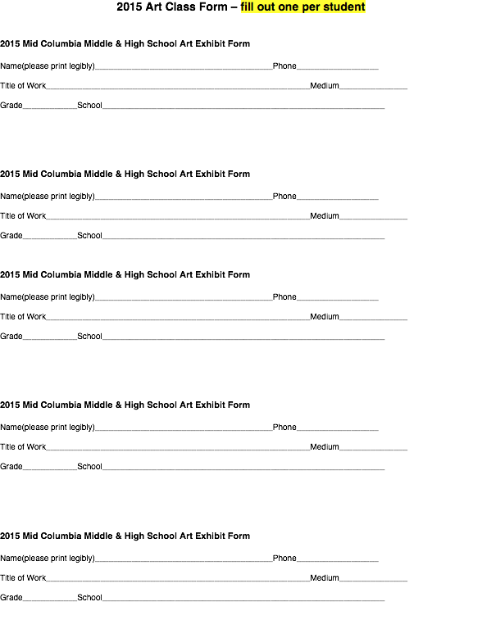

2019

2019

2019

2019

2019

2019

